Request For Service - Barnsley Central Area
Support Service for New Mothers
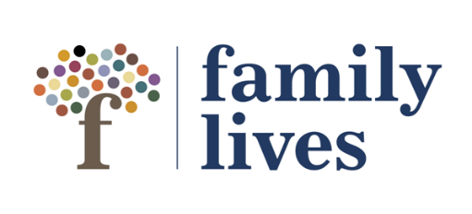
This service is a voluntary option for new mums and their families.
It is free of charge to families and confidential
Consent of the parent needs to be obtained before requesting the service: Has this been obtained? Y / N
Parent’s Name:

Also known as / previous names:

Address:

Contact Telephone No: | E-Mail Address:
Date of Birth: | Gender:
Ethnicity: | Language Spoken:
Immigration Status: | Disability/Additional Needs:
Is mother pregnant? | EDD:

Children’s Details - Please include names of all children under 18.
Name of child  (Eldest child first) | D.O.B | M/F | Ethnic Origin | Additional Needs? | Subject to any of the following:-
 |  |  |  |  | CAF/FCAF | CIN | CPP

Reason for Request for Service

Other Agencies Involved
Agency/Professional Contact Details | Reason for Involvement | Details of Future Meetings: Date, Time, Venue | Tick if aware of RFS

Risk Assessment
 | Not an Issue | Current Issue | Previous Issue | Not Known
Violent Behaviour
Drug or alcohol Use
Mental Health Issues
Offending History
Physical/Emotional Abuse
Guns and Involvement with Gangs
Safeguarding Concerns
Smoking
Pets
Complaints or Grievances Made Against Professionals
Possibility of Others Being Present
Please provide more details where you have identified any current or previous risk:

Please √ all that apply to this family:
Lone Parent | Substance Abuse | Domestic Abuse | Mental Health Issues | Learning Disabilities | PND (Post Natal Depression) | interpreter Required* | Teenage Pregnancy 19yrs or younger | Other – Please Specify
Details of Person Completing the Request for Service Form
Name: | Role:
Agency: | Address:
Post Code: | Contact Telephone No:
E-Mail Address: | Date RFS Completed:
Referrer’s Signature:

Please return to Lesley Brewin at lesleyb@familylives.org.uk
Telephone Number: 07971253308
Remember to offer our helpline number to families that may need support
0808 800 2222. Website – www.familylives.org.uk

