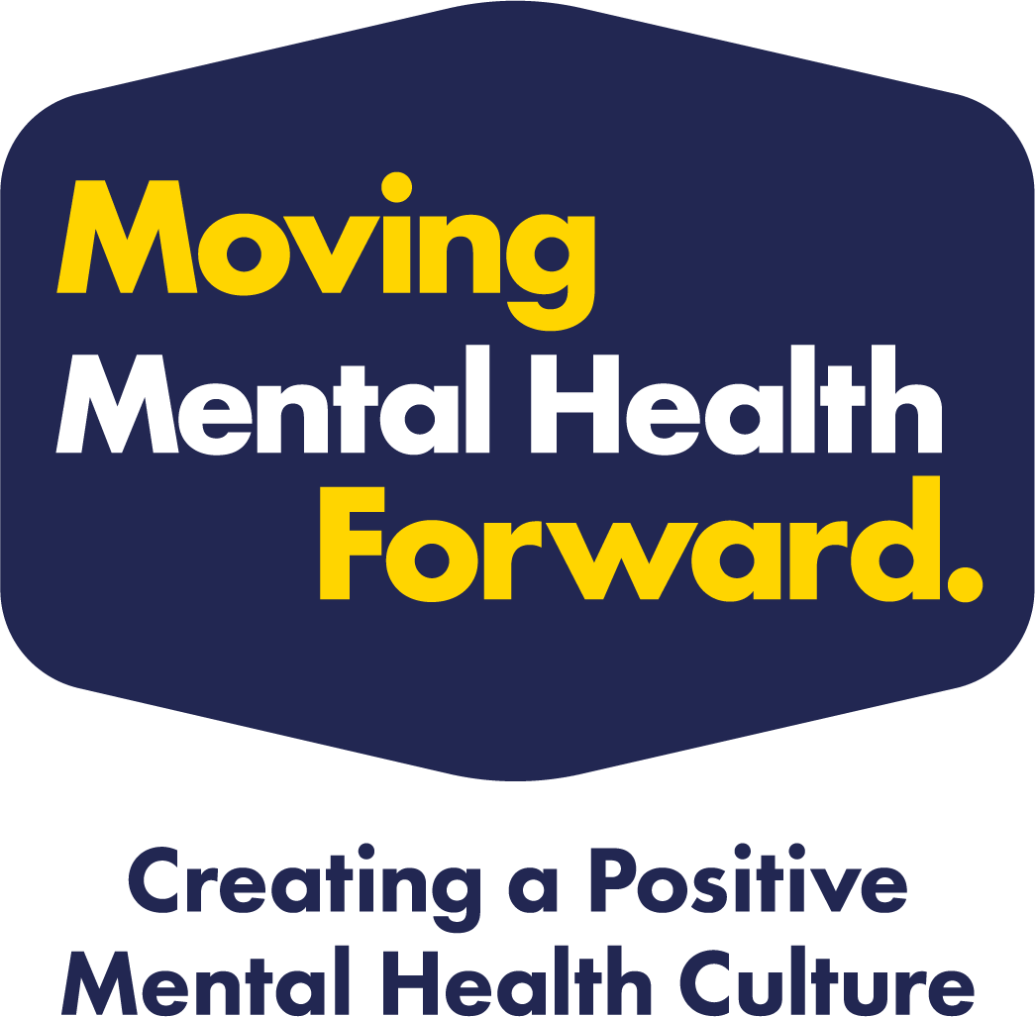

Introduction

Thank you for taking the time to look through the principles that we expect organisations, groups and clubs to meet in order to become a part of the Moving Mental Health Forward Network. We know that in our organisations, groups and clubs, we have contact with lots of people in many different ways, which allows us to communicate, raise awareness, provide support, build each other up and share positivity. If we work together as a network, we would be able to create a significant impact on positive mental health culture across Barnsley.

This scheme has been designed to be a supportive process, and we are here to help organisations, groups and clubs to develop a better awareness of mental health and create a positive culture in their setting. For organisations, groups and clubs that meet the principles of Moving Mental Health Forward, you will be able to display the network logo and have access to a range of promotional and supportive resources, including access to a small grant scheme. We can also support settings to work towards the principles, so please get in touch for any support.

Process

We have tried to make the process as straightforward as possible. There are five principles that we want organisations, groups and clubs to demonstrate a commitment to. While we don't expect every organisation to have everything in place, we want to encourage organisations, groups or clubs to do more and promote a positive mental health culture. That's why we have developed our standard recognition of good practice and a gold standard for those showing innovation and going above and beyond. Both are enormously important in helping people in Barnsley to have improved mental health.

On receiving your completed document and any supporting evidence, we will get in touch to provide some support, if required, or a welcome pack and details on the next steps.

Moving Mental Health Forward – Grant Fund

As well as supporting organisations, groups and clubs with the benefits of being part of the network, we want to help you promote, advocate and activate the things you want to do to support the positive culture with the people in and around your place. Small Grants are available up to £2,000 that can fund many different things. If you are interested, indicate at the end of this document, and we will forward the grant application with the Network welcome pack.
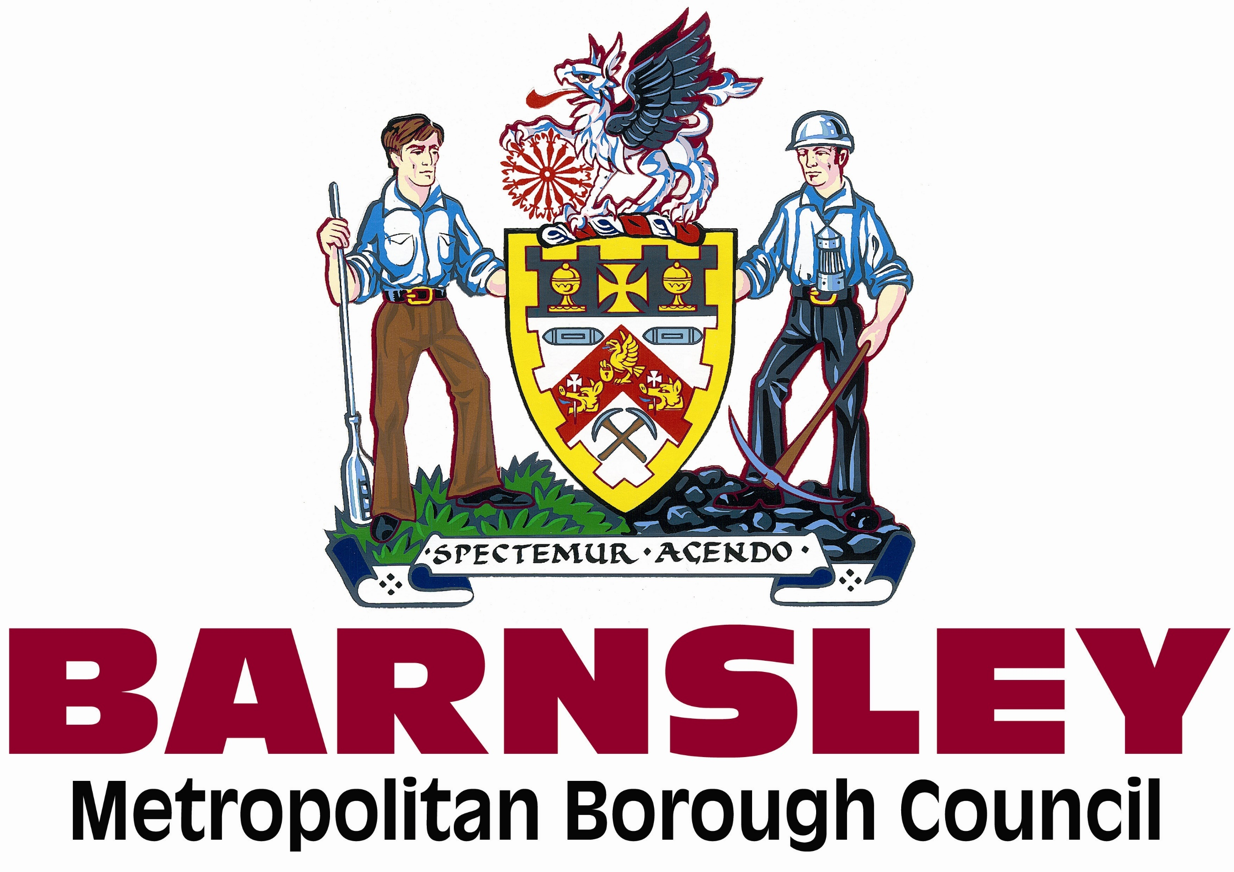

About your Organisation, Group or Club
Organisation/Club/Group name: |  |  |  | Date:
Name of Person Completing: |  | Position:
Contact Email Address: |  | Tel:
Public Contact Information:
(These are the details you are happy for us to use in publicity and on the network webpage)
Website or Facebook page link:
Tell us about your Organisation/Club/Group:  This is so we understand the nature of your club and support the monitoring of the scheme. Best estimates are fine. | Estimate how many direct and indirect people are involved with your organisation, group or club?  (This could be participants, volunteers, supporters, parents, staff etc.)  From the number given above, estimate for each section below the % of that number that are in the follow:  Gender split (100%) Female: Male: Other:  Age breakdown (100%) 0-4: 5-17: 18-25: 25-64: 65+:  People with a disability (100%) People without a disability Not known
Tell us why you would like to be a part of the network:

 | Principle | Rationale  Why? | Operational Indicator  How do we know we are getting it right? | How is your organisation, group or club meeting this principle? Currently and in the future. | Completed
1 | Ensure there is a lead contact(s) in the organisation, group or club to act as the Mental Health Champion. This will be our main contact(s). | Having a point of contact in the club so that we can liaise and provide support via the champions. They will be the link to the wider network.  We would recommend having more than one champion so they can work together and share the load. You may consider more depending on how many sections or the size of your organisations, group or club. | - Identify, appoint, and promote an appropriate person(s) to act as Mental Health Champion on behalf of the organisation.  - People involved with your organisation, group or club are aware of who the champion(s) are.  - Consider how this could be widened for your setting. E.g. Having a supporting champion for each age section, team or different activity. |  | ☐

 | Principle | Rationale  Why? | Operational Indicator  - How do we know we are getting it right? | How is your organisation, group or club meeting this principle? Currently and in the future. | Completed
2 | Ensure that there are appropriately trained Mental Health Champions throughout your organisation, group or club. This will look different for different organisations, groups or clubs of different size. | This is to ensure that there is an embedded understanding and awareness of mental health throughout the organisation, group or club.  For a list of suggested training opportunities, please speak to national governing body or information will be provided to all on the MMHF network.  Here are some examples of training available:  Mental Health First Aid Course  Mental Health Awareness Training  Mental Health Awareness for Sport and Physical Activity  Zero Suicide Alliance | - Number of people who have received some form of mental health training.  - Proof of training accessed.  - Those who are trained are positioned across the activities of the organisation, group or club.  - People are aware of who the main contacts are should someone want to speak to a mental health champion. |  | ☐

 | Principle | Rationale  Why? | Operational Indicator  - How do we know we are getting it right? | How is your organisation, group or club meeting this principle? Currently and in the future. | Completed
3 | Your organisation, group or club will adopt and positively promote the Moving Mental Health Forward Network Charter and help to create a positive mental health culture in what you do.  (The Moving Mental Health Forward Charter is on page 9). | This is something that everyone in the network will join together to help bring to life in their organisation, group or club.  By agreeing to and demonstrating the behaviours in the charter your organisation, group or club will make a difference. Replicated across all the organisations, groups and clubs we will impact across Barnsley together. | - Signed and adopted by senior managers or committee members.  - Displayed at relevant locations across the organisation, group or club. |  | ☐

 | Principle | Rationale  Why? | Operational Indicator  - How do we know we are getting it right? | How is your organisation, group or club meeting this principle? Currently and in the future. | Completed
4 | To promote and advocate positive Mental Health messaging throughout the organisation, group or club helping to affect the people around us. | This will support the positive culture you are trying to develop by helping mental health messages get to the wider people involved with your organisation, group or club. It will help to normalise the conversation and give people to opportunity to speak or find support. | - Include a regular post for mental wellbeing in your newsletters and social media.  - Be involved in local campaigns such as the What’s Your Move campaign, Alright Pal and national mental health related campaigns. We will provide support for this via the Moving Mental Health Forward Network. |  | ☐

 | Principle | Rationale  Why? | Operational Indicator  - How do we know we are getting it right? | How is your organisation, group or club meeting this principle? Currently and in the future. | Completed
5 | Provide and promote contacts of mental health services and crisis services to all members through your communication channels. | Support will be provided as part of the network with contacts, training, information and connections with others to share good practice.  Having and displaying information as an organisation, group or club makes it easier for people to find support. | - Active member of the Moving Mental Health Network.  - Displaying various service information as part of your communications. Website, social media, card handouts etc.  - Being able to respond quickly and appropriately with information when it is required. |  | ☐

 | Is there anything else you would like to tell us about how your club is supporting positive mental health ? | Is there any specific support that you would like as being part of the network?
 | If you would like to access the Moving Mental Health Forward Small Grants, please tick here and we will provide the information. |  | ☐
 | Barnsley Council will collect information for the purpose of the Moving Mental Health Forward scheme which will include promoting your organisation group or club via the network and through our What’s Your Move website. We will use the information that you provide to be used publicly and all other information will be held securely and used to contact you directly in relation to the scheme. You can find out more about our privacy policy at www.barnsley.gov.uk/privacy. I give consent for the information provided to be used as part of the Moving Mental Health Forward scheme (Please tick). |  | ☐

If you have any questions, please don’t hesitate to get in touch with us via email and we can provide some support.
On completion of this, please send the document and any supporting evidence to sport&activerecreation@barnsley.gov.uk

Moving Mental Health Forward Charter
