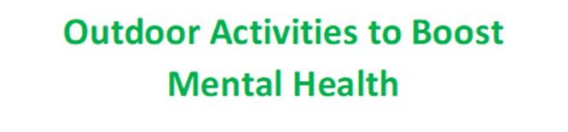

**Registration Form**

PARTICIPANT DETAILS please provide us with your personal information as requested below in order for us to facilitate your participation in our project.

First Name:

Last Name:

DOB: / / /

Gender: Male Female Prefer not to answer

Address:

Postcode:

Participant Contact No:

Participant Email Address:

Emergency Contact No:

Emergency Contact Name:

Emergency Contact Relationship to Participant:

PLEASE NOTIFY US OF ANY RELEVANT MEDICAL CONDITIONS (PHYSICAL OR MENTAL) THAT MAY ADVERSELY AFFECT YOUR PARTICIPATION IN THESE SESSIONS, including details of any medication you may take:

______________________________________________________________________________

CONSENT

In addition to facilitating your participation in our activity sessions, the Project may use personal information as provided by you for profiling and data analysis, and in monitoring

Further, we request your consent to use your personal information in the following ways:

Please tick this box to provide your consent for us to occasionally photograph and / or film you participating in our activity sessions. These photos and / or films may be used for promotional / monitoring purposes and feature across our marketing platforms including but not limited to: match day programmes, websites and social media platforms.

Please tick this box to provide your consent for us to contact you with opportunities for volunteering; training and qualifications; competitions; education and / or employment.

In order to opt out at any time from your personal information being used in any of the above ways, you can do so by contacting the project staff team.

Signed _______________________________________ Participant

Name _______________________________________

Signed _______________________________________ Parent / Guardian (if participant is not able to give consent themselves)

Name ________________________________________

Return to Fiona Hall, Community Engagement Manager, Shaw Lane Sports Club, Shaw Lane, Barnsley S60 6HZ

[foundation@shawlane.com](mailto:foundation@shawlane.com)

