Information Sheet

This page will tell you about our study so that you can see if you can help us.
The workshop
The workshop will be held on the computer. There will be other autistic people there. The researchers will ask you all questions. The questions are about the help you get and whether that help could be better. There are no right or wrong answers.

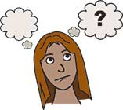
Why are we asking these questions?
Your answers will help us to make sure that autistic people get the right help.

Who are we looking for?
If you were diagnosed with autism in the last ten years and were given the diagnosis when you were eighteen or over, you can take part if you want to.

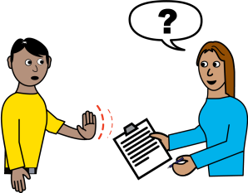
Your decision
You do not need to take part. It is up to you. If you change your mind, you can stop taking part at any time and do not need to tell us why.

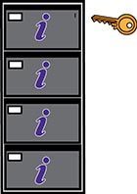
Keeping your information confidential
What you say in the workshop will be kept private. The only time the researchers would tell someone else what you said would be if you or someone you talk about is at risk.
Who are the researchers?
Dr Megan Freeth, Dr Daniel Poole and Susanna Crowson work at the University of Sheffield. Together they do research with and for autistic people.

If you want to find out more
If you want to find out more, you can email m.freeth@sheffield.ac.uk
Tell us about it over the phone by calling +44 114 222 6652

If you are not happy
If you are not happy about the research email e.milne@sheffield.ac.uk
Tell us about it over the phone by calling +44 114 222 6558

Thank you for your help

